Trees - Non-linear Data Structure- not in order

Binary Tree :
A binary tree is a tree-type non-linear data structure with a maximum of two children for each parent.
Parent node (or) Root Node
10

12
11

Child node 1 child node 2
Left Reference Right Reference

Every node in a binary tree has a left and right reference along with the data element. The node at the top of the hierarchy of a tree is called the root node. The nodes that hold other sub-nodes are the parent nodes

A tree whose elements have at most 2 children is called a binary tree. Since each element in a binary tree can have only 2 children, we typically name them the left and right child.

Perfect Binary Tree

A tree is a perfect binary tree if all the internal nodes have 2 children, and all the leaf nodes are at the same level.
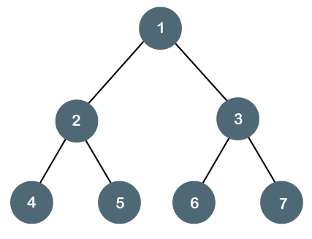

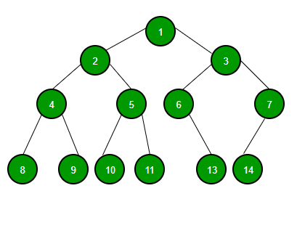
The tree can only be considered as the full binary tree if each node must contain either 0 or 2 children.

Binary Search Tree:

A Binary search tree is a tree that follows some order to arrange the elements, whereas the binary tree does not follow any order.

In a Binary search tree, the value of the left node must be smaller than the parent node, and the value of the right node must be greater than the parent node.

Binary Search Tree Data Structure
Binary Search Tree is a node-based binary tree data structure which has the following properties:
- The left subtree of a node contains only nodes with keys lesser than the node’s key.
- The right subtree of a node contains only nodes with keys greater than the node’s key.
- The left and right subtree each must also be a binary search tree.
- There must be no duplicate nodes.
Insert 8,3,10,1,6,14,4,7,13 using Binary Search Tree

The parent node element is 8 ( key element)

parent node element 8 having two child (or)leaf node 3( left ) is less than the parent node element 8 and 10 ( right) is greater than the parent node element 8

The parent node element is 3 ( key element)
parent node element 3 having two child node 1( left) is less than 3 and 6(right) greater than the root node element (3)

Difference between Binary Tree and Binary Search Tree:
BINARY TREE | BINARY SEARCH TREE
BINARY TREE is a non linear data structure where each node can have almost two child nodes | BINARY SEARCH TREE is a node based binary tree which further has right and left subtree that too are binary search tree.
BINARY TREE is unordered hence slower in process of insertion, deletion and searching. | Insertion, deletion, searching of an element is faster in BINARY SEARCH TREE than BINARY TREE due to the ordered characteristics
IN BINARY TREE there is no ordering in terms of how the nodes are arranged | IN BINARY SEARCH TREE the left subtree has elements less than the nodes element and the right subtree has elements greater than the nodes element

